# Deployment Notes:

Current Module TWIN properties:

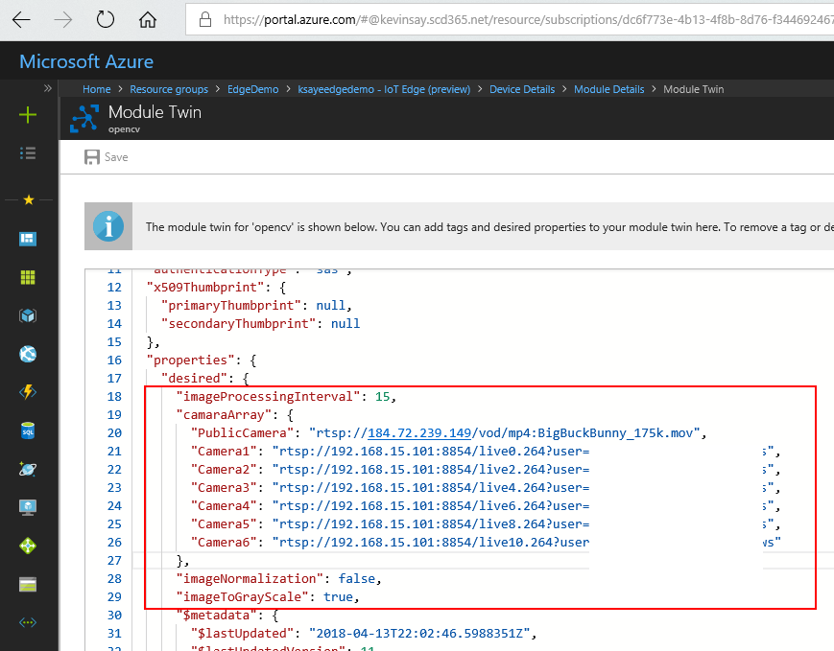

Deployment options, if you want to access the images via the host:

URL: ksayeedgedemo.azurecr.io/opencv:0.0.1-amd64

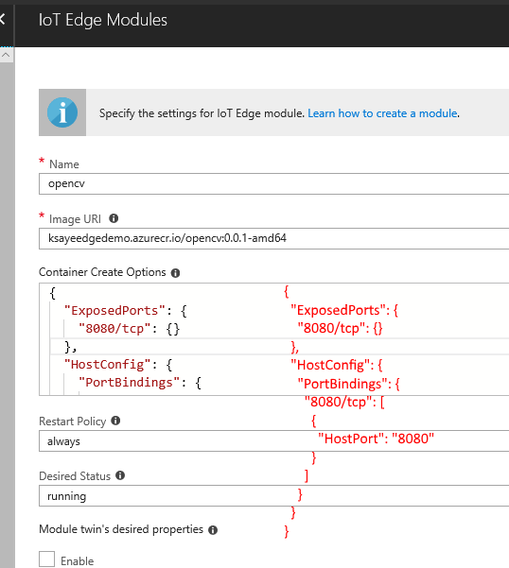

Actual module running:

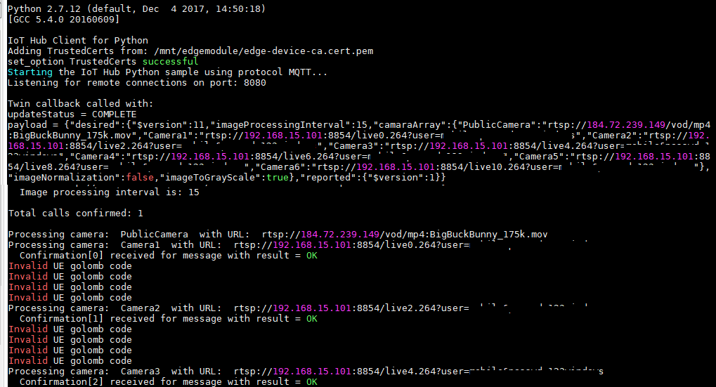

Route Example:

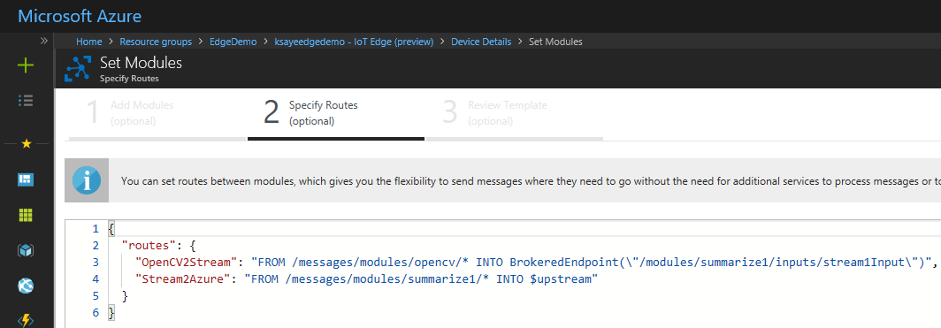Log file from Stream, which messages were routed to:

